STEM
What is a sustainable city?
A sustainable city is a city that meets the needs of its residents while protecting the environment. Sustainable cities are important for the future because they reduce environmental damage, use resources well, and create healthier communities for future people living there.
Singapore sustainable city
This city I chose was Singapore. Singapore uses many sustainable ideas, including extensive public transport, green buildings, urban parks, and water recycling systems. These sustainable ideas reduce pollution and improve the quality of life for people living there by creating a cleaner and healthier environment. One idea I think is especially effective is Singapore’s efficient public transport network because it reduces traffic congestion.
My Sustainable City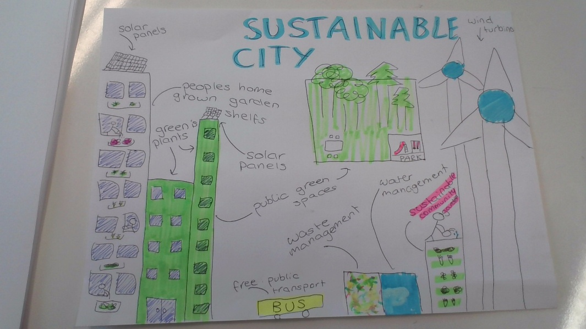
My sustainable city is designed to protect the environment while making life better for everyone. People move around the city using free public transportation, such as buses, which reduces the number of cars on the road. Pollution is also reduced through the use of solar panels on buildings and wind turbines that produce renewable energy. The city includes green buildings with plants, home garden shelves, and big public green spaces that give people a nice place to enjoy nature. Water and waste management systems help recycle resources and keep the city clean. These features create a healthier, cleaner, and more enjoyable community where people can live and also protect the environment.

Virtual City
City Feature | Appearance in VR | Shape or Object
Solar-Powered Apartment Building | Tall white smart tower with glowing rooftop solar panels and illuminated windows showing residents' activities | Rectangular Prism
Green Residential Tower | Bright green eco-building covered in living plants and vertical gardens | Tall Rectangle
Home Garden Shelves | Floating garden platforms attached to buildings where users can grow virtual vegetables and flowers | Small Cubes
Rooftop Solar Panels | Shiny blue-black panels that glow when generating energy | Flat Rectangle
Vertical Green Walls | Animated walls covered with climbing plants and flowers | Green Rectangle
Public Green Space | Large interactive park with trees, walking paths, and wildlife sounds | Circle
Urban Forest | Dense cluster of digital trees with moving leaves and birds | Cylinder (tree trunk) with Sphere (tree canopy)
Children's Park | Play area with slides, swings, and climbing frames that users can interact with | Triangle and Cube Combination
Wind Turbines | Giant rotating turbines with glowing blades that display energy output | Cylinder with Three Triangles
Water Management System | Transparent blue reservoirs and flowing water channels showing water movement | Blue Cube
Waste Management Center | Smart recycling station with color-coded bins and sorting animations | Cube
Sustainable Community Garden | Multi-level garden where users can plant crops and learn about food production | Stack of Rectangles

About Virtual City
The most important parts of my virtual city are the solar-powered buildings, wind turbines, and green spaces. When people enter the city, they would first see the eco-friendly buildings and parks. They could move around by walking or using free electric buses. It may be difficult to show how energy, water, and waste systems work in a simple 3D world.

